

**Southern River College**

**Year 12 Physics**

**Electromagnetism Test**

**Time allowed for this paper**

Working time for paper: 55 minutes

**To be provided by the supervisor:**

This Question/answer booklet;

Formulae and constants sheet

**To be provided by the candidate**

Standard items: Pens, pencils, eraser or correction fluid, ruler, highlighter

Special items: Drawing instruments or templates.

A **scientific** (i.e., non-graphics) calculator satisfying curriculum council requirements.

**Structure of this paper**

|  |  |  |  |  |  |
| --- | --- | --- | --- | --- | --- |
| Section | Number of questions available | Suggested working time  (minutes) | Your Mark | Marks available | Percentage of test |
| Section One:  Short answer | 6 | 19 |  | 21 | 35% |
| Section Two:  Extended answer | 3 | 25 |  | 27 | 45% |
| Section Three  Comprehension | 1 | 11 |  | 12 | 20% |
|  |  | **Total** |  | 60 | 100 |

**Important note to candidates**

No other items may be used in this test. It is your responsibility to ensure that you do not have any unauthorised notes or other items of a non-personal nature in the test room. If you have any unauthorised material with you, hand it to the supervisor before reading any further.

**Instructions to candidates**

1. Write answers in this Question/Answer Booklet in the spaces provided.
2. To achieve full marks, clear, logical working and diagrams MUST be shown.
3. When calculating numerical answers, show your working or reasoning clearly. Give final answers to **three** significant figures and include appropriate units where applicable.

When **estimating** numerical answers, show your working or reasoning clearly. Give final answers to a maximum of **two** significant figures and include appropriate units where applicable.

1. You must be careful to confine your responses to the specific questions asked and follow any instructions that are specific to a particular question.

**Section A**: Short Answer (21 Marks)

1. Consider the following:
   1. For each of the following, describe the force acting on the wire as either up, down, left, right, into page, out of page or no force:

|  |  |
| --- | --- |
|  | Force: |
| [Image result for magnetic field out of page](https://www.google.com.au/url?sa=i&source=images&cd=&cad=rja&uact=8&ved=2ahUKEwjkyL6K1qzbAhXIVbwKHbJRABcQjRx6BAgBEAU&url=http://lrrpublic.cli.det.nsw.edu.au/lrrSecure/Sites/LRRView/13936/13936_03.htm&psig=AOvVaw0pIg1k-aU19-fq8V_CLylx&ust=1527743471934386)  **** | Force: |
| ****  N  S  N  S | Force: |

(3 Marks)

* 1. A soft ferromagnetic spanner is placed near the magnet. Draw the resulting field:

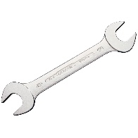

(2 Marks)

1. Frictionless braking involves using magnetic fields to induce eddy currents in the rotor. This converts kinetic energy into electrical energy, thus slowing the car.

On the diagram below, around the points marked ‘A’ & ‘B’, indicate the direction of the eddy currents in the aluminium rotor disc as it turns through the magnetic field (the direction of the magnetic field is indicated in the greyed-box as being out-of-the-page):

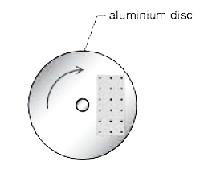

**B**

**A**

(2 Marks)

1. Consider the following coils:
   1. The current in coil X is increasing. Draw an arrow to show the direction of induced current in coil Y. (1 Mark)

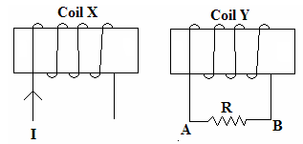

* 1. Given that the area of each loop of the coil is 1.00 x 10-2 m2 and the magnetic field in coil Y increases from 0.01 T to 0.03 T in 2 ms, calculate the magnitude of the induced emf in *each loop*. (2 Marks)

1. The magnetic flux versus time graph for a particular coil of a wire in a generator is given below. (3 Marks)

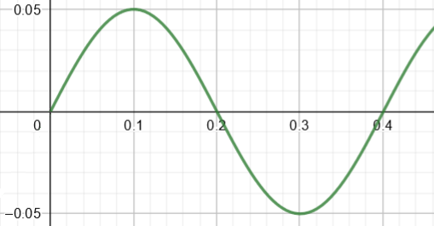

Φ (Wb)

Time (ms)

At what time(s) are:

1. The rate of change of flux zero? _________________________
2. The rate of change of flux a maximum? _________________________
3. The peak EMF supplied? _________________________
4. Consider the following setup; the resistor has a resistance of 6.00 Ω, the distance between the two plates is 1.20 m, and the bar is being pulled through a constant magnetic field of 2.50 T.
5. Calculate the speed at which the bar should be moved in order to produce a current of 0.50 A through the resistor:



(3 Marks)

1. Is the current flowing in a clockwise or counter-clockwise direction?

(1 Mark)

1. Consider a straight wire carrying a current of ‘*I’*. A student calculates the magetic field strength at a distance of 0.07m from the wire as having magnitude *‘B’*.

1. Find, in terms of *‘B’*, the strength of the magnetic field at a distance of 56.0cm from the wire. (2 Marks)
2. The diagram below shows the current in the wire going into the page. Complete the diagram by drawing the magnetic field around the wire (draw at least 4 field lines). (2 Marks)

**END OF SECTION A**

**Section B**: Extended Answer (27 Marks)

1. An aeroplane flies from Perth airport, heading directly south at 215 km h-1. At a certain point in its flight, the Earth’s magnetic field strength is 3.26 x 10-5 T and the angle of dip is 40.0° to the horizontal. As the plane flies a potential difference develops between the wing tips.
2. Calculate the component of the Earth’s magnetic field which is causing the potential difference. (2 Marks)
3. If the wing tips are 15.5 m apart, calculate the value of the potential difference. (2 Marks)
4. Determine which wing tip (left or right from the pilot’s point of view) will have the higher potential. (1 Mark)
5. The coil pictured below is free to rotate about its axis; it has been placed in a magnetic field of 9.08 mT. The coil consists of 25 turns; a current of 2.20 A is passing through it. The coil is rectangular, with length = 55.0 mm and width = 35.0 mm.

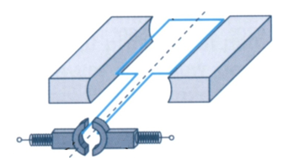

‘device’

1. Find the magnitude of the maximum torque produced by the motor. (3 Marks)
2. What is the name and purpose of the ‘device’? (2 Marks)
3. On the graph below, sketch how the torque varies as the motor is rotated through 360° from being horizontal. (3 Marks)

τ

0° 90° 180° 270° 360°

1. List three ways in which the torque could be increased. (3 Marks)

1)__________________________________________________________________

2)__________________________________________________________________

3)__________________________________________________________________

1. Nitrogen-14 ions **(N3-)** of mass 2.33 x 10-26 kg and triple negative charge are accelerated from rest in a potential difference established between 2 charged parallel plates. The parallel plates have a potential difference of 5000 V across a gap of 8.00 cm. You can ignore the effects of gravity and air resistance in this question.

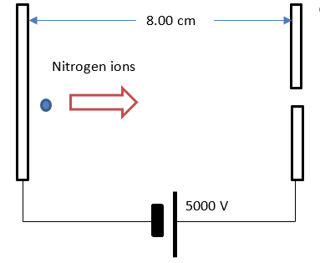

* 1. Calculate the electric field strength between the parallel plates.

(2 Marks)

* 1. Calculate the magnitude of the electric force that acts on the Nitrogen ions in this electric field.

(2 Marks)

* 1. Calculate the maximum speed reached by the Nitrogen ions as they move between the parallel plates.

(3 Marks)

The Nitrogen ions are fed into a uniform magnetic field within a mass spectrometer. The ions enter at a speed of 4.54 x 105 m s-1. The magnetic field has a uniform flux density of 123 mT. The set up and the direction of the magnetic field is shown in the diagram below.

Vacuum chamber of mass spectrometer – magnetic field indicated

Nitrogen ions

• • • • • •

• • • • • •

• • • • • •

• • • • • •

* 1. Draw an arrow on the diagram to show the general direction that the nitrogen ions will follow.

(1 Mark)

* 1. The force acting on the Nitrogen ions due to the magnetic field will cause it to follow a circular path. By equating the magnetic force to centripetal force (FB = FC), derive an expression to calculate the radius of the path taken by the nitrogen ions in the mass spectrometer, and state this value.

(3 Marks)

**END OF SECTION B**

**Section C**: Comprehension (12 Marks)

1. In the diagram below a Copper rod is free to slide down two parallel electrical contact rails which are mounted on an inclined plane. The inclined plane is a strong magnet. The angle, θ, between the inclined plane and the horizontal can be changed. The electrical contact rails are connected to a galvanometer.



As the rod slides, it first accelerates but eventually reaches a constant, terminal speed.

* 1. Explain why a current is detected by the galvanometer when the Copper rod moves.

(2 Marks)

* 1. Explain why there is a force opposing the rod’s motion down the rails.

(2 Marks)

A group of students investigate the relationship between the terminal speed of the rod and the angle of inclination. They measure the terminal speed of the rod using data logging equipment and the angle of inclination with a protractor. They plot their data on a graph. This graph is reproduced below.



* 1. Describe the trend in uncertainty for the terminal speed and the sine of the angle θ.

(2 Marks)

* 1. Draw a line of best fit onto the graph and determine the gradient of the line. If there were any points that you felt needed to be disregarded before drawing your line of best fit, circle these points on the graph and explain why you chose to disregard them.

(3 Marks)

* 1. The rod’s terminal speed can be calculated from the equation:



Given *m* = 44.0 g, *R* = 1.4 × 10-4 Ω and *l* = 20.0 cm, use your value of the gradient to calculate a value of the magnetic field strength *B*. If you were unable to determine a value for the gradient you should use 1.57 cm s−1.

(3 Marks)

**END OF TEST**

Spare Page: